Kafka Boost High Level Architecture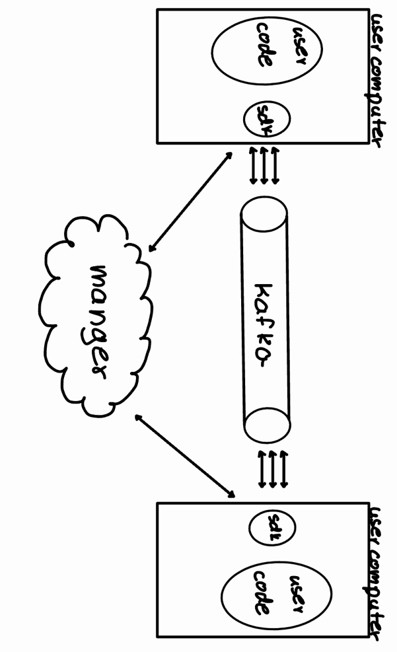

1. System Main Components
The proposed system is a wrapper for Kafka designed to manage priority-based requests in distributed systems. It introduces a structured way to handle topics and groups, with the main components detailed below:

1.1 SDK (Software Development Kit):
- Functionality:
  - Routes requests from a group to a specific priority, represented as a Kafka topic.
  - Sends requests to Kafka while listening to topics within the appropriate group.
  - Sorts incoming requests by priority based on predefined metadata.
- Deployment: Installed on the client side for every user utilizing the system.

1.2 Manager:
- Functionality:
  - Converts groups into Kafka topics for each system using the product.
  - Manages metadata defining priorities (e.g., user type, request type).
  - Allows users to define and update priorities via metadata.
  - Metadata configuration occurs during initial setup and can only be modified by restarting the SDK.

1.3 API:
- Provides interfaces for:
  - System configuration.
  - Updating priorities and metadata.
- Simplifies the integration process for client applications.

2. Main User Use Cases

2.1 Use Case 1: Submitting a Request
- The client application sends a request with priority metadata to the SDK.
- The SDK routes the request to the appropriate Kafka topic within the group.
- Kafka processes the request and forwards it to the consumers.

2.2 Use Case 2: Listening to Requests
- The SDK listens to the relevant Kafka topics in the group.
- It retrieves and sorts incoming requests based on priority.
- The requests are processed by the client application in the correct order.

2.3 Use Case 3: Updating Metadata
- The user modifies priority definitions in the Manager.
- The Manager updates the metadata for the relevant groups and topics.
- The SDK requires a restart to apply the updated metadata.

3. Back-End Technology
- Core Messaging System: Kafka, extended with the custom wrapper for priority handling.
- Manager Implementation:
  - Programming Language: Python or
  - Database: PostgreSQL for metadata storage.
- API: RESTful API for configuration and updates.
- Deployment: Dockerized services for scalability and flexibility.

4. Front-End Technology

4.1 Technologies
- Framework: React.js for building a user-friendly dashboard.
- State Management: Redux or Context API for managing system configurations.
- Styling: Tailwind CSS for responsive and modern design.

4.2 Draft for Main Screens
- Login Screen:
  - Fields for username and password.
  - "Forgot Password" link.
- Dashboard:
  - Displays groups and their associated Kafka topics.
  - Visual indicators for priority levels and request statuses.
- Metadata Configuration Screen:
  - Allows users to define or modify metadata for groups and topics.
  - Includes fields for user types, request types, and priorities.
- API Testing Panel:
  - Provides tools to test API endpoints.
  - Displays request and response logs.

5. Additional Considerations

5.1 Scalability
- Horizontal scaling supported via Docker and Kubernetes.
- Kafka’s inherent scalability ensures high throughput.

5.2 Fault Tolerance
- Metadata changes require SDK restarts to avoid misalignment during updates.
- Redundant Manager instances ensure high availability.

5.3 Security
- Authentication using OAuth 2.0.
- Encrypted communication channels (HTTPS).

6. Conclusion
The proposed Kafka Boost enhances distributed systems by introducing priority management to Kafka topics. The SDK, Manager, and API components collectively create a robust system for efficiently handling requests based on predefined priorities. By leveraging Kafka’s strengths and adding an intelligent priority layer, this solution streamlines communication and ensures high-priority tasks are processed first.

